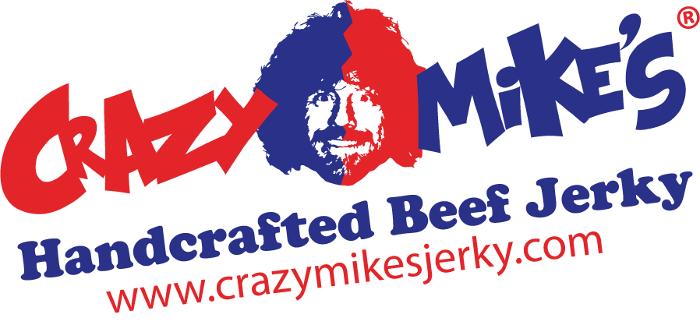

Patient Name:

Diagnosis: Acute Jerkynemia

A relief for bad beef jerky has been discovered. By following the prescription below, the Patient should make a full recovery.

Terms of Prescription:

- ____ Bags of Crazy Mike’s Handcrafted Beef Jerky per month for ____ months.
- Eat as needed to treat hankerings for a high-quality beef jerky. Can be taken on an empty stomach, a full stomach, with any beverage of your choice; there are no restrictions.
Refills: ____ (prescription quantity can be changed at any time; contact the Prescriber)
Prescribed by:

SCRIPT

